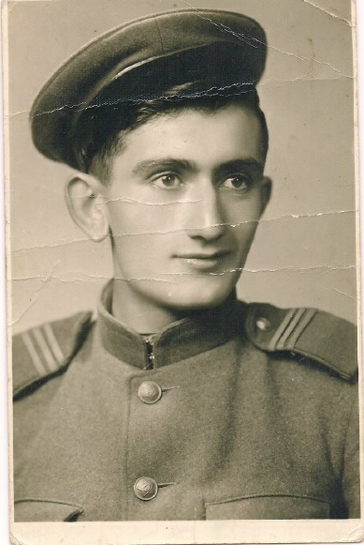
When I was a child, I often talked to my grandfather. I loved stories about the Great Patriotic war. The heroism, will to win amazed me, but at the same time I was horrified by bloody events of that time. Though my grandfather, Hovanes Petrosovich Melikyan (1924 - 2015), didn’t like to remember military actions, he told me about his participation in the war.
My grandfather was among the first people to join the army. At the beginning of the war he was 17 years old. His subdivision located in Georgia was a military unit of the Southern Front. In this part of the country several important battles took place. Soldiers defended Donbass, Barvenko-Lozovaia, Stalingrad, Kharkov. During these operations my grandfather got injured in knee. After rehabilitation he continued participation in military actions in the 4th Ukrainian front. He liberated Rostov-on-Don, Donbass, Crimea. The last operation was The Prague Offensive from 6 May to 11 May 1945. Over 800 000 enemy soldiers were captured. But, unfortunately, my grandfather got another injury in his hip. It was more difficult and he recovered completely only after the war. My grandfather went very hard way, was promoted to a higher rank and awarded numerous medals.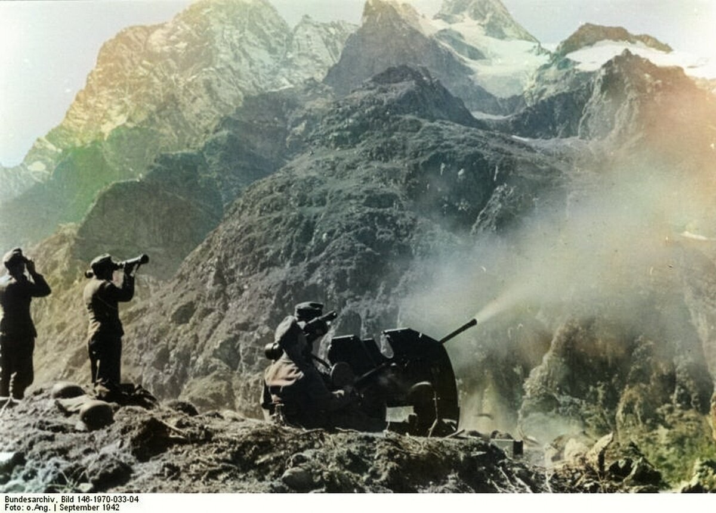
Melikyan Hovanes Petrosovich (1924 - 2015)
The courage of the soldiers, tenacity and the desire to defend their Homeland arouse respect and reverence. Any war is a terrible and bloody event and it leaves a “print” for the whole life. My grandfather saw a lot of horrible things and deaths on the front. And even 60 years later, he remembered them. He could not watch war movies and other things referring to it. I am proud of my grandfather and I always honor his memory.

Robert Melikyan
Group ICS 8-22

